

YEAR: 9
2017
SUBJECT: Science

TEST: Waves
TIME: 40 minutes
QUESTIONS: 15 Multiple Choice (15 marks)
4 Short Answer (15 marks)
TOTAL MARKS: 30 marks

DO NOT WRITE ON OR MARK THIS PAPER
SECTION ONE—MULTIPLE CHOICE (15 marks)

This section has 15 questions. Answer all questions on the separate Multiple-choice Answer Sheet provided.

1. The number of times per second that an object vibrates is called its

a) wavelength.
b) oscillation.
c) frequency.
d) amplitude.

2. The pitch of a musical note is

a) amplitude
b) the quality
c) the size of the vibration
d) the frequency

3. In an experiment at sea level, an explosive charge was detonated at the waters edge, represented by point X on the diagram.

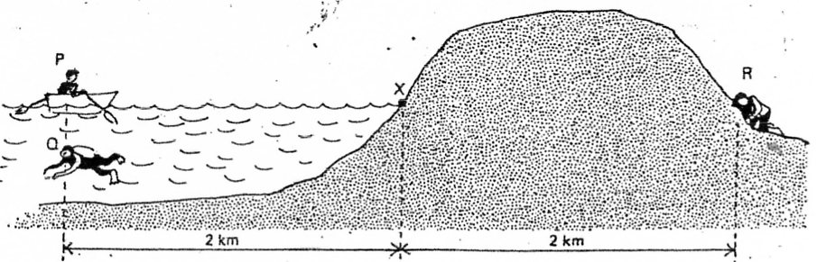

Three observers were located at equal distances from X. P in a boat, Q underwater and R with his ear to the ground.

Which one of the following statements is correct?

a) R hears the explosion first, then Q, then P.
b) P and Q hear the explosion first, at the same time.
c) P hears the explosion first, then Q, then R.
d) P and R hear the explosion first together, then Q.
4. Sound is a longitudinal wave. This means that its particles:

a) vibrate back and forth
b) move along with the wave
c) vibrate from side to side
d) do not move at all

5. The speed of electromagnetic waves travelling in a vacuum is equal to:

- 300 000 metres per second
- 300 000 000 metres per second
- 300 000 000 kilometres per second
- 330 metres per second

6. Two types of wave may be generated by using a slinky. The particles in the slinky can be moved in the same direction as the wave. What type of wave is made when this happens?

a) Transverse only
b) Longitudinal only
c) Transverse and longitudinal
d) Neither transverse nor longitudinal

7. The frequency of a note played on a piano is 128 Hz. The frequency of another note known as Middle C is 256 Hz. What can you tell me of the pitch of the first note compared to Middle C?

a) Higher than middle C
b) Lower than middle C
c) Same pitch as middle C
d) Louder than middle C

8. Combining all the colours of light together makes

- white
- black
- cyan
- red
9. An echo is an example of a sound wave
- refracting
- reflecting
- diffracting
- total internal reflection

10. A diamond has a beautiful sparkle because the light gets trapped inside it for a while before it emerges. What phenomena explain this?

- Refracting
- Reflecting
- Diffracting
- Total internal reflection

11. The volume of a musical note is

a) the amplitude
b) the quality
c) the size of the vibration
d) the frequency

12. When putting a pen into a glass of water, the pen bends. This bending of light is known as

- refracting
- reflecting
- diffracting
- total internal reflection

13. A magnify glass, which focuses the light rays into a single point uses what type of lens?

- Mirror
- Concave
- Convex
- Convolution

14. Sound moves fastest in

- warm air
- warm water
- cold water
- cold steel
15. In a longitudinal wave, what is it called when the particles are spread far apart?

- Compression
- Rarefaction
- Amplitude
- Wavelength

SEMESTER TWO 2017
Waves Test:
ANSWER BOOKLET

NAME:
FORM: DATE:

Multiple Choice Short Answer Total

/15

/15

/30

SECTION ONE: Multiple choice answers
Cross (X) through the correct answer.

1 | a | b | c | d
2 | a | b | c | d
3 | a | b | c | d
4 | a | b | c | d
5 | a | b | c | d
6 | a | b | c | d
7 | a | b | c | d
8 | a | b | c | d
9 | a | b | c | d
10 | a | b | c | d
11 | a | b | c | d
12 | a | b | c | d
13 | a | b | c | d
14 | a | b | c | d
15 | a | b | c | d
SECTION TWO: Short Answer (15 marks)

Answer the questions in the spaces provided.

1. “In Space, no one can hear you scream” is a quote from the movie “Alien”. Explain why this quote is true. (2 marks)
_________________________________________________________________________________
_________________________________________________________________________________
_________________________________________________________________________________
_________________________________________________________________________________
2. The audio frequency oscillator was producing the following sound wave on the cathode ray oscilloscope.

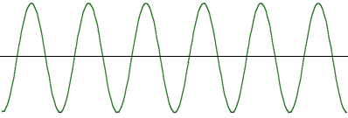
a) Draw below what the wave will look like if the frequency of the sound were to increase (2 marks)

b) Draw below what the wave will look like if the original sound were louder (2 marks)

3. Draw a diagram of a light ray hitting a mirror and obeying the Law of Reflection. Be sure to label the normal, the angle of incidence and angle of reflection. (4 marks)

4. Isaac Newton identified the seven colours of the rainbow.
a) What are they? (3.5 marks)
R_____________________
O_____________________
Y_____________________
G_____________________
B_____________________
I______________________
V_____________________

- What are the three primary colours for light? (1.5marks)

- ______________________________
- _____________________________
- _____________________________

END OF TEST

